The Evolution of AI Agents and Modern AI Engineering
AI agents have evolved from simple prompt-based LLM applications into systems that can reason, call tools, store memory, plan multi-step work, and collaborate in multi-agent teams. Modern AI engineering is now about designing these systems as reliable software architectures rather than treating the model as a standalone chatbot.^{[1][2][3][4]}
Introduction
Large language models first became widely useful as general-purpose text generators, but their limits soon became clear: they could not reliably look up facts, execute actions, or maintain long-running state. That gap led to a new engineering pattern in which the LLM becomes the reasoning core of a larger system that includes retrieval, tools, memory, planning, and coordination.^{[3][5][4]}
This shift is important because many real tasks are not single-turn language problems. They require decomposition, verification, repeated tool use, and adaptation when new information appears, which is exactly what agentic systems are designed to support.^{[4][6][1]}
LLM Applications
LLMs are used in chatbots, coding assistants, document summarization, knowledge work automation, and decision support. Their main strength is flexible language understanding and generation, but they work best when paired with external systems for accurate facts, computation, or action execution.^{[5][3]}
A practical example is a customer-support assistant that drafts replies, searches a product database, checks order status, and escalates unresolved cases. Another example is a software assistant that explains code, generates test cases, and uses repository tools to inspect files or run tests.^{[1][3]}
AI Agents
An AI agent is a system that receives a goal, reasons about it, takes actions, observes results, and updates its behavior. In modern designs, the agent is not just the model; it is the full loop of perception, planning, action, and feedback.^{[4][1]}
A useful way to think about an agent is as a digital project manager. It breaks a task into steps, chooses which tool to use, checks whether the result is good enough, and then decides the next step.^{[6][4]}
Tool Calling
Tool calling lets an LLM invoke external functions such as search APIs, calculators, databases, calendars, code runners, or enterprise systems. Toolformer showed that language models can learn when to call tools, what arguments to pass, and how to incorporate the results into future generation.^{[3]}
This makes systems more accurate and more useful because the model no longer has to “guess” everything from its internal parameters. ReAct also showed that interleaving reasoning and acting improves task solving by letting the model update its plan after each observation.^{[1]}
Memory
Memory gives an agent continuity across turns and tasks. In practice, this can include short-term conversation state, long-term user preferences, retrieved documents, and procedural traces from past workflows.^{[7][8][5]}
Retrieval-augmented generation is a foundational memory pattern because it combines parametric model knowledge with non-parametric external memory. Later work extended this idea with more selective, dynamic, and long-context memory mechanisms to improve factual recall and long-horizon reasoning.^{[8][5][7]}
Planning
Planning is the process of deciding the order of actions needed to reach a goal. Survey work on LLM planning groups the field into task decomposition, plan selection, external modules, reflection, and memory, showing that planning is now a central part of agent design.^{[4]}
A planning loop usually looks like: define goal, split into subtasks, select tools, execute, observe, and revise. This is why many agent systems behave like iterative workflows instead of one-shot prompts.^{[1][4]}
Multi-Agent Systems
Multi-agent systems use several specialized agents instead of one monolithic agent. AutoGen demonstrated that multiple agents can converse with each other to accomplish tasks, which makes it easier to separate roles such as planner, researcher, critic, and executor.^{[2]}
This design improves scalability and can make complex workflows easier to manage, but it also introduces coordination overhead and more failure points. Recent research on procedural memory in multi-agent workflows suggests that where memory is placed matters: orchestrator memory helps task decomposition, while agent-level memory improves execution accuracy.^{[9][6]}
Future of AI Engineering
The future of AI engineering is moving toward compound systems that combine reasoning, retrieval, tool use, memory, planning, and oversight. Agentic RAG and related systems show that these architectures are becoming more dynamic and sequential, with richer control policies and more explicit state transitions.^{[6]}
Future work will likely focus on reliability, evaluation, governance, and safety. As agents become more autonomous, engineers will need stronger monitoring, better tool permissions, safer memory handling, and clearer methods for judging whether a system actually solved the task correctly.^{[6][4]}
Architecture Diagram 1
Diagram description: Single AI agent architecture.
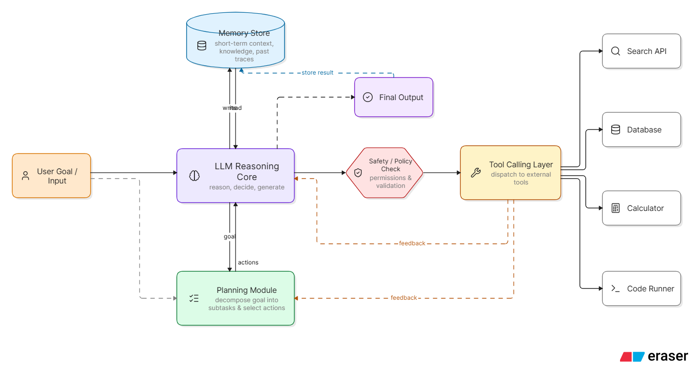
Architecture Diagram 2
Diagram description: Multi-agent system architecture.
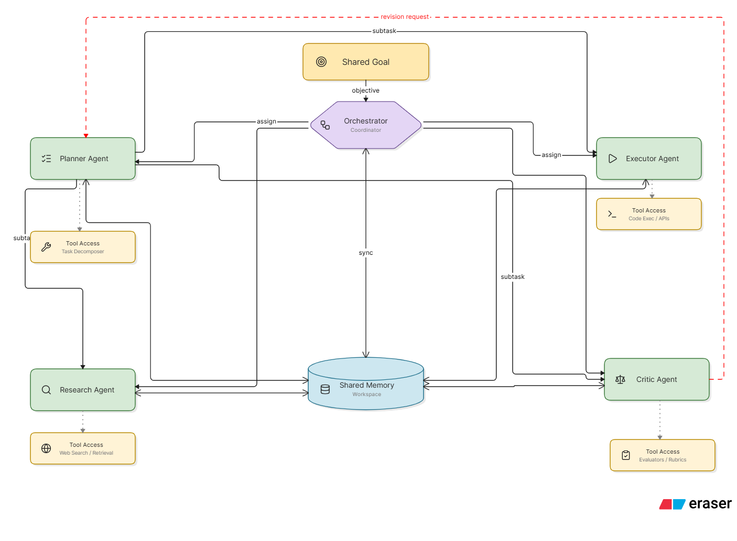
Real-World Examples
One real-world example is Microsoft’s AutoGen framework, which is designed for building applications through multi-agent conversation rather than a single prompt-response cycle. Another example is Toolformer-style tool use, where the model learns to trigger calculators, search engines, translation tools, and calendars to improve task performance.^{[2][3]}
A good modern workflow example is an agent that receives a business request, searches internal documents, retrieves data from a database, drafts a report, and then asks a critic agent to check for errors before final delivery. That kind of pipeline illustrates how planning, memory, and tool calling combine in practice.^{[2][4][6]}
References
- Yao, S. et al. “ReAct: Synergizing Reasoning and Acting in Language Models.” arXiv, 2022.^{[1]}
- Schick, T. et al. “Toolformer: Language Models Can Teach Themselves to Use Tools.” arXiv, 2023.^{[3]}
- Wu, Q. et al. “AutoGen: Enabling Next-Gen LLM Applications via Multi-Agent Conversation.” arXiv, 2023.^{[2]}
- Lewis, P. et al. “Retrieval-Augmented Generation for Knowledge-Intensive NLP Tasks.” arXiv, 2020.^{[5]}
- Huang, X. et al. “Understanding the Planning of LLM Agents: A Survey.” arXiv, 2024.^{[4]}
- Qian, H. et al. “MemoRAG: Boosting Long Context Processing with Global Memory-Enhanced Retrieval Augmentation.” arXiv, 2024.^{[7]}
- Gutiérrez, B. J. et al. “From RAG to Memory: Non-Parametric Continual Learning for Large Language Models.” arXiv, 2025.^{[8]}
- Han, D. et al. “LEGOMem: Modular Procedural Memory for Multi-agent LLM Systems for Workflow Automation.” arXiv, 2025.^{[9]}
- “SoK: Agentic Retrieval-Augmented Generation (RAG): Taxonomy, Architectures, Evaluation, and Research Directions.” arXiv, 2026.^{[6]}
⁂

- https://arxiv.org/abs/2210.03629
- https://arxiv.org/abs/2308.08155
- https://arxiv.org/abs/2302.04761
- https://arxiv.org/abs/2402.02716
- https://arxiv.org/abs/2005.11401
- https://arxiv.org/abs/2603.07379
- https://arxiv.org/abs/2409.05591
- https://arxiv.org/abs/2502.14802
- https://arxiv.org/abs/2510.04851
- https://sukruyusufkaya.com/en/blog/tool-calling-planning-ve-memory-guvenilir-ai-agent-mimarisi-nasil-kurulur
- https://arxiv.org/html/2603.22862v2
- https://hyper.ai/en/papers/2601.14192
- https://arxiv.org/html/2506.08234v2
- https://medium.com/@bravekjh/langmem-structured-memory-for-llms-in-multi-turn-multi-agent-systems-50a81614bb96
- https://fast.io/resources/tool-calling-persistent-memory/
- https://arxiv.org/html/2508.08997v2
- https://www.youtube.com/watch?v=9yDyOsleIaQ
- https://www.youtube.com/watch?v=HjTrLVYIpys
- https://arxiv.org/abs/2412.01262
- https://huggingface.co/buckets/rl-llm-wiki/rl-the-gatherer/tree/sources/arxiv-2210.03629/summary.md
- https://arxiv.org/abs/2510.01253
- https://arxiv.org/abs/2304.11116
- https://arxiv.org/html/2405.13966v1
- https://arxiv.org/abs/2303.11381
- https://arxiv.org/abs/2506.11475
- https://arxiv.org/abs/2601.02428
- https://arxiv.org/html/2603.01783v1
- https://arxiv.org/html/2504.01346v4
- https://arxiv.org/abs/2504.05312v4
- https://www.agentarxiv.org/papers/cmlvmoeea000bh9zhzil84oix

